STATIC CONCRETE PUMPS
www.ramcrete.co.uk
01628 782 860

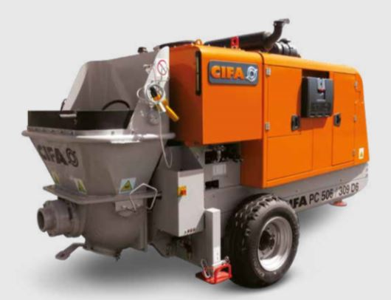

Technical data Cifa P506 / 309
Delivery Cylinder | 176mm
Delivery Stroke | 1000mm
Output | Max *52m3/hr / ^34m3/hr
Delivery pressure | *57 Bar / ^ 91 Bar
Strokes per minute | *36 / ^ 24
Engine Power | 72kw
Weight | 3400kg
Pressure connection | 5 inch
* Rod side ^ Piston side
Generic Length 4315mm , Width 1570mm , Height 2175mm

